Runoff change scenarios based on regional climate change projections

in mountainous basins in Slovakia

1Štefunková Z., 1 Hlavčová K., 2Lapin M.

1Faculty of Civil Engineering, Slovak University of Technology in Bratislava, Radlinského 11, 813 68 Bratislava, Slovak Republic

2Faculty of Mathematics, Physics and Informatics, Comenius University in Bratislava, Mlynská dolina, F-1, SK-84248 Bratislava, Slovak Republic

e-mail: zuzana.stefunkova@stuba.sk, kamila.hlavcova@stuba.sk, [lapin@fmph.uniba.sk](mailto:lapin@fmph.uniba.sk)

Abstract:

In the study the potential impact of climate change on river runoff in the upper Hron River, Váh River, and Laborec River basin was evaluated using the Hron conceptual spatially-lumped rainfall-runoff model, which was driven by regional circulation models of atmosphere. The rainfall-runoff model was calibrated with data from the 1981-1995 period and validated with data from the 1996-2010 period. Changes in climate variables in the future were expressed by three different regional climate change projections: KNMI, MPI and ALADIN-Climate for the period 1961-2100. Changes in the seasonal runoff distribution were evaluated by a comparison of the simulated long-term mean monthly discharges in the river basin outlets in future decades with the present stage.

Key words:

Climate change, regional circulation models (RCMs), Hron rainfall-runoff model, SRES A1B emission scenarios.

1. Introduction

Human activities that are changing the emissions of greenhouse gases are continuously affecting the Earth’s climate across our planet. The most compelling evidence of climate change derives from observations of the atmosphere, land, oceans, and cryosphere (IPCC, 2013). Figure 1 demonstrates a significant increase in the mean annual air temperature (by 1.8°C in a 132-year pe­riod) and an insignificant decrease in annual areal precipitation totals (by about 1.3% in 132 years) in Slovakia. While the increase in air temperature is nearly the same in the whole territory, a decrease in the annual precipitation totals was mainly observed in the south of Slovakia (up to 10%); a small increase in precipitation totals is only at the northern border of Slovakia (about 3%). These trends of the air temperature and precipitation were accompanied by a decrease in the relative air humidity and an increase in the potential evapotranspiration by about 5% in the south of Slovakia.

The latest period of 1980-2012 was significant in Slovakia not only due to the rapid increase in air tempera­ture (by about 2°C), but also due to the great variability in the precipitation totals (164% of the normal in 2010, 74% of the normal in 2003), which caused several episodes of serious droughts on the one hand and local or regional floods on the other. Changes in the winter precipitation totals and an increase in the winter air tempera­tures also caused unstable snow conditions. Only in the higher mountains an increase in the number of days with snow cover was recorded (but altitudes above 1000 m a.s.l. cover only 5.4% of the Slovak territory).

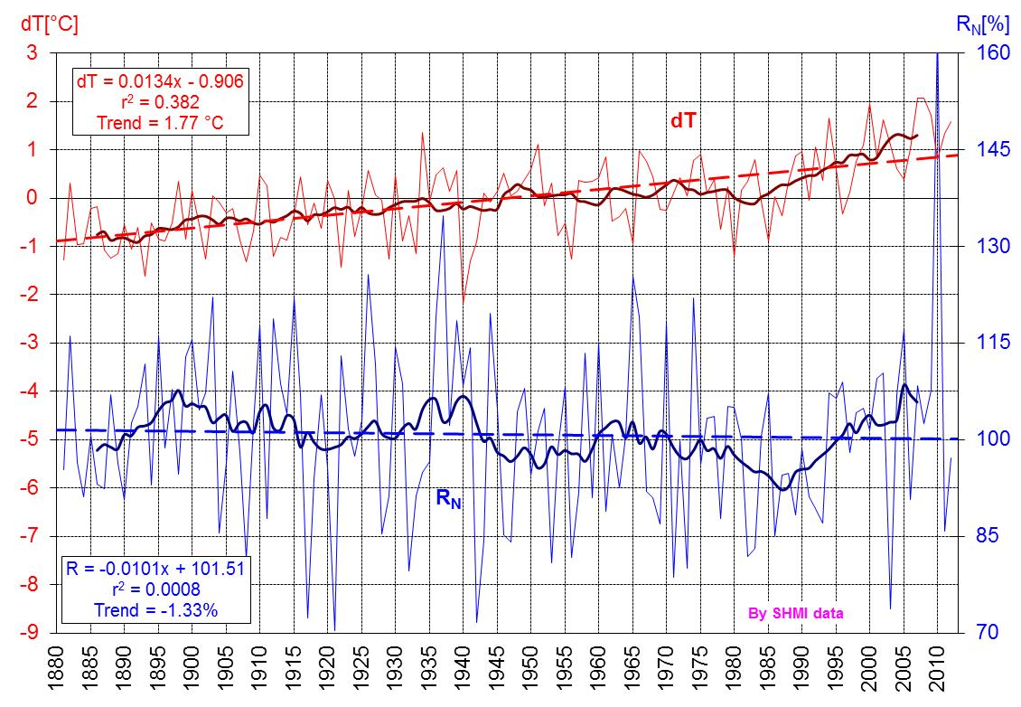

Fig. 1. Deviations in the mean annual air temperature (dT) in Slovakia (based on 3 stations) from the 1951-1980 normal and annual areal precipitation totals (RN) in Slovakia (based on 203 stations) as a percentage of the normal 1901-1990 in the period 1881-2012, including 11-year moving averages and the linear trend (according to the SHMI data).

The issue of climate change is a term used very frequently, especially in its relationship with global warming. Possible changes in runoff conditions due to climate change are currently one of the main sources of uncertainty in the long-term planning of water resources and flood protection. Floods in Central Europe have caused deaths and widespread property damage across parts of the Czech Republic, Germany and Austria. Such events are likely to increase in Europe for several reasons, including climate change, according to recent assessments from the European Environment Agency (EEA). Periods of drought are likely to increase for all of Europe as well. These results were processed using EEA simulations in 2012 on the basis of 11 RCMs and SRES A1B emission scenario.

The impacts of climate change on hydrological processes are often estimated by developing scenarios of changes in climatic inputs to a hydrological model from the output of general circulation models (GCMs). As was reported in the IPCC Fourth Assessment Report (IPCC, 2007), most hydrological impact studies have been based on global rather than regional climate models. The basis of the model output problem lies in a mismatch of the scale between the global climate models and the hydrological models. While the outputs from a GCM represent a spatial resolution of several tens of thousands of square kilometers, catchment based hydrological models require data with a resolution of a few square kilometers.

Therefore, climate models have continued to be developed and improved. The development and use of Regional Circulation Models (RCMs) has grown; their resolution has increased; descriptions of the process have developed further; new components have been added; and coordinated experimentation has become more widespread (Laprise, 2008; Rummukainen, 2010). Since the Fourth Assessment Report (AR4) quiet a few authors have dealt with the problem of climate change impacts using RCMs, e. g., Maurer, et al. (2007); Alexandru, et al. (2009); Bresson, et al. (2011); Cha, et al. (2008); Crétat, et al. (2012); Diffenbaugh, et al. (2011); Hernández-Díaz, et al. (2013) and Kawazoe, et al. (2013).

Several climate change impact studies have also been conducted for the territory of Slovakia. Usually, three types of climate change scenarios have been used in impact studies: analogue scenarios based on an analogy with warmer periods and periods with a speci­fied variability in the climate in the past (WP and SD); regionally downscaled GCM scenarios (CCCM, GISS, GFDD3) with typical time ho­rizons of 2010, 2030 and 2075; and incremental climate change scenarios. Modified time series of climate data for future time horizons have usually been constructed from the baseline data by adding the differences in mean air temperature and precipitation prescribed by the scenarios for the given time step. An observed series of climate characteristics from 1931–1980 or 1951−1980 has usually been considered as the representative baseline data. Additional details can also be found in the following studies on Slovak river basins: Danihlík, et al. (2004); Halmová (2006); Halmová and Melo (2006); Hlavčová, et al. (2002, 2005, 2008); Kostka and Holko (2000, 2001); Kostka (2003); Majerčáková (2000); Majerčáková and Takáčová (2001); Pekárová, et al. (2001); Pekárová (2000); Pekárová and Miklánek (2001); Pekárová and Szolgay, eds. (2005); Szolgay, et al. (2002, 2003, 2007a,b) and Macurová, et al. (2010, 2012).

In this paper the potential impact of climate change on river runoff in the upper Hron River, Váh River, and Laborec River basin was evaluated using the Hron conceptual spatially-lumped rainfall-runoff model, which was driven by regional climate models. The rainfall-runoff model was calibrated with data from the 1981-1995 period and validated with data from the 1996-2010 period. Changes in climate variables in the future were expressed by three different regional climate change projections: KNMI, MPI and ALADIN-Climate for the period 1961-2100.

1. Methodology

For developing hydrological scenarios of runoff in future time horizons, the following methodological approach was applied:

1. Developing climate change scenarios by downscaling outputs of the KNMI, MPI and ALADIN-Climate regional circulation models to selected climate stations or grid points in Slovakia,
2. calibrating and validating parameters of a rainfall-runoff model for the selected river basins using measured input climate and hydrological data from the calibration and validation period representing the present stage,
3. simulation of the hydrological characteristics using a rainfall-runoff model driven by climate data from downscaled RCM outputs for the reference period 1961-1990 and two future time horizons of 2021-2050 and 2071-2100,
4. evaluation of changes in the seasonal runoff redistribution by comparing the long-term mean monthly discharges in the river basin outlets in future decades with the present stage.
5. **Hron hydrological model**

For modeling runoff characteristics under changed climate conditions, the Hron rainfall-runoff model was applied. The Hron rainfall-runoff model (Valent, 2012) is a conceptual model with lumped parameters that simulates runoff from a river basin in a daily time step. Input data for the model represent the basin’s averages of measured mean daily air temperatures, daily precipitation totals, and daily potential evapotranspiration. The structure of the Hron model is based on three sub-models (Fig. 2): Snow, soil and runoff sub-models.

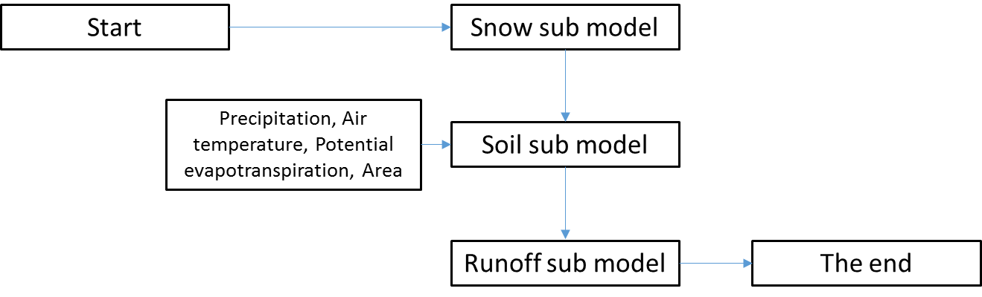

Fig. 2 Structure of the Hron rainfall-runoff model (Valent, 2012)

The function of the snow sub-model is to simulate the accumulation and melting of snow in the river basin with the simple degree-day factor (DDF) method. This method is unassuming for input data, but can achieve results as good as more complex, energy-based models.

The soil sub-model represents hydrological processes that occur below the soil surface, including the infiltration of water from melted snow into the soil, the distribution and accumulation of water in soil, the evapotranspiration of water from a soil profile, and the formation of surface, subsurface and groundwater runoff (baseflow). The soil-sub model can be considered as two hypothetical reservoirs aligned one above the other that represent a supply of soil water and groundwater.

The runoff sub-model is used to transform the total runoff, which consists of surface runoff, subsurface runoff and baseflow, through a river basin. As a transformation function, in this version of the model, we chose a simple triangular weighting function, which can be calculated as:



Rising limb of the hydrograph

Decreasing hydrograph limb

Middle of the hydrograph

A maxbas is a parameter expressing the number of days in which a flow is divided, e.g., i = {1, 2, … q}, and ‘q‘ is the untransformed outflow runoff from a river basin.

1. Climate change scenarios

Climate change scenarios have been gradually prepared for Slovakia since 1993 as modified outputs from several General Circulation Models (GCMs); some scenarios were designed as analogues of the previous warmer climate. A review of those scenarios was also published in five previous Slovak National Communications on Climate Change (SNCCC, 1995, 1997, 2001, 2005, 2009). In this study climate change scenarios developed by downscaling the three regional circulation models KNMI, MPI and ALADIN-Climate were used.

1. KNMI and MPI

Two climate change scenarios used in this study were based on outputs from the KNMI (Dutch) and MPI (German) regional circulation models, which were downscaled for the territory of Slovakia in a daily time step (Lapin, et al., 2012). These models belong to the newest category of so-called coupled atmosphere-ocean models with more than 10 atmospheric levels and more than 20 oceanic depths of model equations and the integration of variables in a network of grid points. The KNMI and MPI regional circulation models (hereinafter “RCMs”), represent a more detailed integration of the atmospheric and oceanic dynamic equations with a grid point resolution of about 25x25 km, while the boundary conditions are taken from the ECHAM5 GCM. The KNMI and MPI RCMs have 19 x 10 grid points (190) in Slovakia and its surroundings with a detailed topography and an appropriate expression of all the topographic elements larger than 25 km. All the RCMs offer outputs of several variables with a daily frequency for the period from 1951 to 2100. Based on these outputs and the measured meteorological data (1961-1990), the daily scenarios for about 30 climatological and about 50 other precipitation stations in Slovakia have been designed. Scenarios for the following variables have mainly been prepared: the daily means, maxima and minima of the air temperature, the daily means of the relative air humidity (all measured at a 2 m elevation above the ground), daily precipitation totals measured at a 1 m elevation above the ground, daily means of the wind speed measured at a 10 m elevation above the ground, and daily totals of the global radiation. These scenarios and user manuals can be easily used to prepare studies on impacts from and vulnerability to climate change.

1. ALADIN-Climate

The ALADIN-Climate model was developed by an international consortium of several European countries and North African countries, led by France. Its history dates back to the early 1990s, when it was developed and used only for the downscaling of short-term weather forecasts (72 hours) produced according to the GCM APREGE at Météo-France. The first study based on research on longer-term predictions was made ​​in 1995 (Janišková, 1995). The results showed that the model is suitable for providing stable and sufficiently accurate results of a presentation of the climate and no accumulation of destructive biases have been observed.

Later, after the year 2000, the same version of the model from the year 1995 was tested independently by CNRM/Météo-France and the Czech Hydrometeorological Institute (CHMI). The results confirmed the stability of the model, which has proved itself to be useful and functioning well enough for obtaining reliable information about the climate in Central Europe for the purpose of experiments relating to current and past climates. Recently, the model was also used for research purposes on climate change in several national and international projects such as the EC FP6 ENSEMBLES (Hewitt and Griggs, 2004) and the EC FP6 CECILIA (www.cecilia-eu.org).

As part of the CECILIA sixth framework program of the European Union (EU FP6 project CECILIA), the ALADIN-Climate/CZ regional climate model was created to provide information about the future climate conditions in high resolution on the territory of Central Europe. In contrast with many regional models (grid points), the ALADIN-Climate/CZ model was created as a spectral model.

For the validation of the model the method of creating a new grid data file of observation stations has been used and tested by CHMI on the territory of the Czech Republic. Given that the model orography with a 10 km resolution does not match the real locations of the stations, the observation stations were located on the model at the position of the altitude by the application of a local linear regression. Subsequently, the measured values at the stations were converted ​​ according to the new altitude; this procedure was repeated for each grid each day. The next step was an interpolation of the reduced values to the positions of the grid points according to the inverse distance weighting method. To interpolate these values, at least 3 and a maximal 7 nearby stations were used. Subsequently, a detailed statistical analysis was made ​(Štěpánek, 2008).

The results demonstrated the ability of the model to reproduce the various hydrological characteristics, such as precipitation and air temperature; therefore, the method was extended and used to create the model outputs for the whole of Central Europe. The creation of a grid database of observation stations corresponding to the RCM ALADIN (10 x 10 km) was made for the territory of Slovakia under the CECILIA project, and the design was performed in the same way as for the Czech Republic. The previous results from testing the model were confirmed by this new method. The model is able to capture the essential features of the current climate of Central Europe (Austria, Czech Republic, Slovakia, Hungary). It works reliably even on a relatively small area with a complex orography. The ALADIN-Climate/CZ scenario (the ALADIN-Climate) was based on the APREGE global model and the IPCC A1B emission scenario (Štěpánek, 2008), and the outputs of the climate scenarios are in a daily step. The reference period for the model is the same as for the MPI and KNMI models (1961-1990). The outputs from the ALADIN-Climate model are for the reference period and the two future periods 2021-2050 and 2071-2100.

A comparison of three climate scenarios based on the outputs of the MPI, KNMI and ALADIN-Climate RCMs for the Váh River basin is presented using the basin’s averages of the long-term mean monthly air temperature and precipitation totals in Fig. 2.

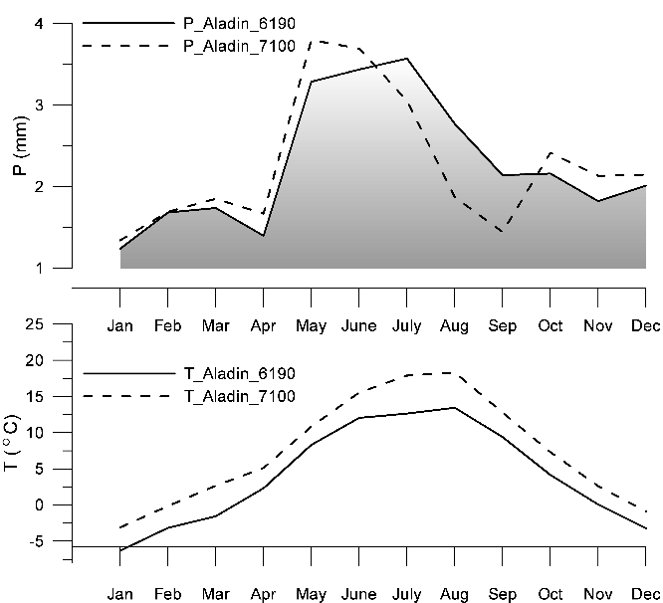 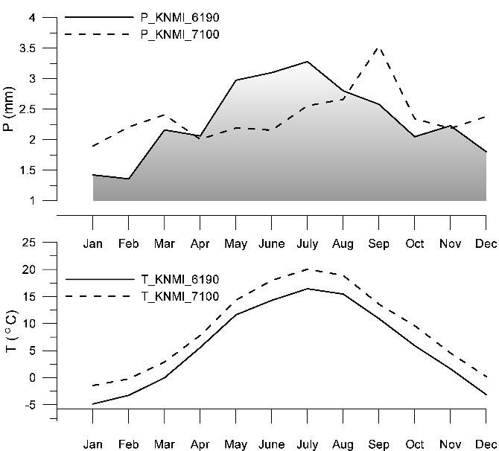

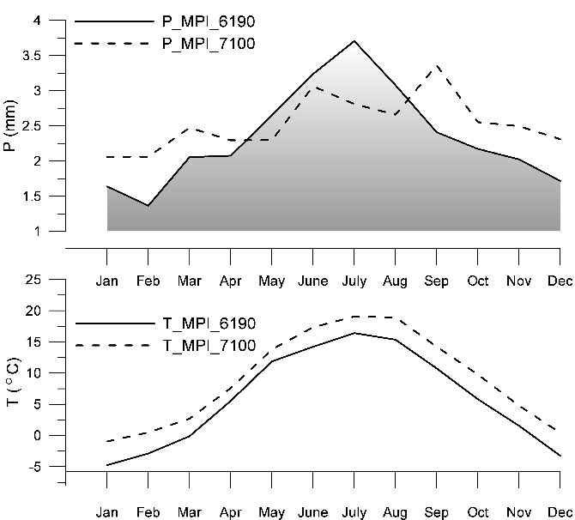

Fig. 2 Comparison of the basin’s averages of the long-term mean monthly air temperature (⁰C) and precipitation totals (mm/day) for three regional climate change scenarios KNMI, MPI and ALADIN-Climate for the Váh River basin.

From the comparison of the latest time horizon of 2071-2100 with the horizon of 1961-1990 it can be seen an increase in the long-term mean monthly air temperatures in all months according all the three RCMs.

The comparison of the long-term mean precipitation totals according to the KNMI and MPI RCMs indicates an increase in monthly precipitations in winter and spring moths from January to March (April) and a decrease from May to August. Changes in the seasonal distribution of precipitation are evident; the shift of maximum monthly precipitation from July to September causes a significant increase in precipitation in September, with the following slight increase from October to December.

According to the Aladin-Climate RCM the period of 2071-2100 in the comparison with the period of 1961-1990 indicates an increase in the long-term mean monthly precipitation totals in months from March to June and from October to December. A decrease is seen from July to September. These changes are caused by the shift of maximum monthly precipitation from July to May and minimum monthly precipitation from November to September.

1. Description of the pilot area and input data

This study was performed for three selected river basins located in Slovakia: the Hron River Basin to its outlet at Banská Bystrica, the Váh River Basin to its outlet at Liptovský Mikuláš, and the Laborec River Basin to its outlet at Humenné. The river basins of the Váh River and Hron River are located in the central part of Slovakia; the river basin of the Laborec River represents the conditions of the eastern part of Slovakia (Fig. 3).

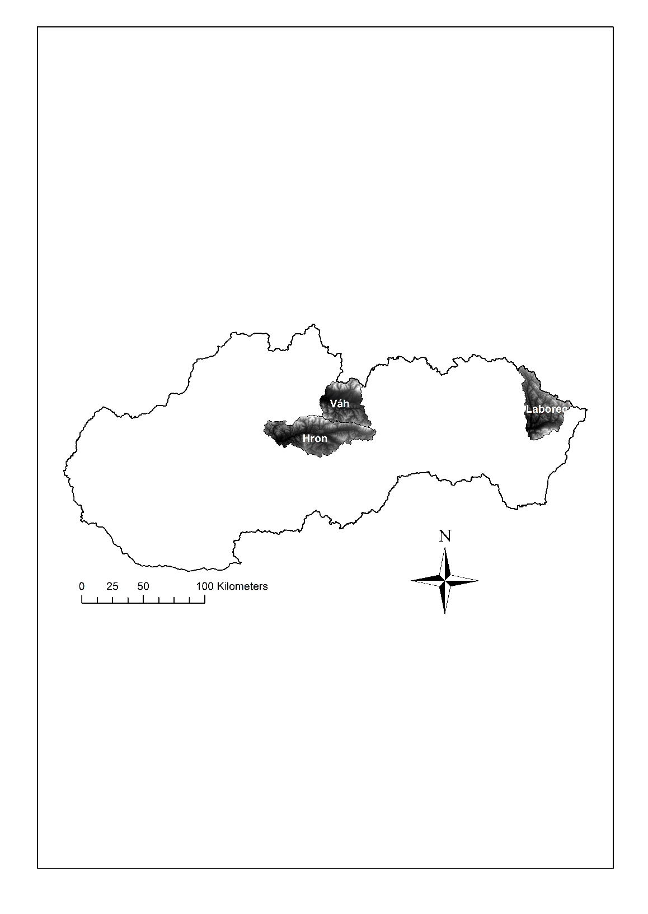

Fig.2 Location of the three selected river basins within the Slovak Republic.

The selected river basin of the upper Hron River to its outlet at Banská Bystrica with an area of 1767 km2 contributes to the total catchment area by 32%. This basin has a border to the north with the Váh River basin, at the eastern part with the Hornád River basin, and to the south with the Slaná River basin. The highest peak of the basin is 2043 m above sea level. The average annual air temperature in the lowermost part of the upper Hron River Basin reaches 6-8 ˚C. With an increase in the altitude, it drops to 4-5 ˚C (Slovenské Rudohorie mountains), respectively at 2-3 ˚C (the Low Tatras) (HEP, 1993). The average annual rainfall in the catchment was 979 mm during the period 1931-1980. The upper Hron River Basin is characterized by a spring regime of high flows concentrated over three months, i.e., from March to May, during which the long-term average flow represents 41% of the annual runoff volume.

The Váh River is the longest river in Slovakia. Its length is 403 km, and the total catchment area represents 19, 696 km2. It rises in the geomorphological unit of the Low Tatras. This basin is the highest basin located throughout the three basins considered. The average altitude of the basin is 400 – 800 m above sea level with the highest peak with almost 2500 m above sea level. The largest part of the upper Váh River basin to the Liptovský Mikuláš profile (sub-basin area of 1, 108.5 km2) belongs to a cold region (86% of the area) with average temperatures ranging from 1 °C to 7 °C. In warm areas an average temperatures ranges from 7 °C to 10 °C. The long-term mean annual precipiatation for the warm areas are 500-550 mm. The rainfall increases towards the mountains, and at the peaks of the Low Tatras, and the Western Tatras the annual rainfall is up to 2000 mm. The highest average monthly rainfall occurs in July or June, and the lowest usually in February.

The Laborec River is 129 km long, and the total catchment area is 4, 522.5 km². The Laborec River rises in the Low Beskydy at an altitude of 682 m above sea level above the village of Čertižné; up to the Humenné profile, the basin covers an area of 1, 281.3 km². In the valleys of the river there are frequent temperature inversions that are more significant in the cold half of the year, when the inversion layer reaches a greater thickness. The average air temperature is 9 7 °C, where the part of the basin that belongs to an area with an altitude lower than 400 m above sea level belongs to a warm climate zone, which is characterized by more than 50 days of summer (with a maximum air temperature of 25 °C or higher). The areas with an altitude 800 m above sea level belong to a cold zone that is very moist; the average July temperature is below 16 ° C. The average total annual rainfall is 591 mm, 352 mm of which falls during the growing season.

1. Calibration and validation of the parameters of the Hron rainfall-runoff model

To simulate runoff characteristics under the present and changed climate conditions, the Hron rainfall-runoff model was applied (described in Chapter 2.1). The parameters of the hydrological model were calibrated for the 15-year period of 1981 - 1995. This period was selected as a period representing the current state. The period for the validation of the model parameters was 1996 - 2010.

To calibrate the model parameters, manual as well as automatic calibration was used. With a manual calibration, the parameters of the model are adapted by entering their values​​ based on experience, where the combination is then evaluated based on the chosen optimization criterion. An automatic calibration is based on the use of optimization methods and the introduction of optimization algorithms to the model. Its objective is to investigate so many combinations of parameters that a set of parameters for which the model meets the best value of the selected optimization criterion is successfully found. The advantages of an automatic calibration compared with the manual one is that it is less demanding in terms of time and can investigate far more combinations of parameters; moreover, the user does not have to be so professionally educated in the problematics of calibration.

Within the automatic calibration the methods of genetic algorithms and harmony search have been tested. Compared to a harmony search genetic algorithms were more time consuming, but with them it was possible to achieve a higher value of the Nash-Sutcliffe coefficient (N-S), which was used as an optimization criterion for the calibration.

The sufficiency of the Hron model with the calibrated parameters to simulate the runoff characteristics for the selected river basins was tested by comparing the measured and simulated discharges in the basin outlets. The graphs in Figs. 4, 5 and 6 illustrate a comparison of the long-term mean monthly discharges for the entire calibrated period and the mean daily discharges for the selected year of 1995. The values of the Nash-Sutcliffe criterion for the calibration and validation periods are presented in Table 1.

Table 1. The values of the Nash-Sutcliffe criterion for the calibration and validation periods.

|  |  |  |
| --- | --- | --- |
|  | **N-S for calibration period** | **N-S for validation period** |
| **Váh** | 0.77 | 0.61 |
| **Hron** | 0.77 | 0.82 |
| **Laborec** | 0.79 | 0.75 |

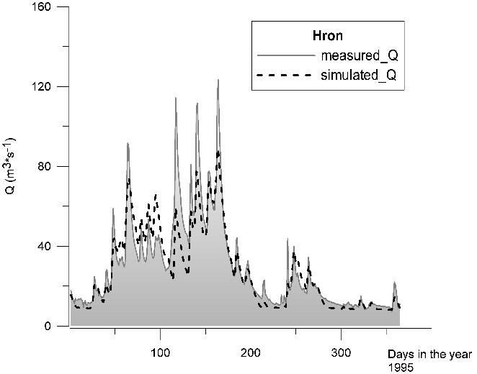 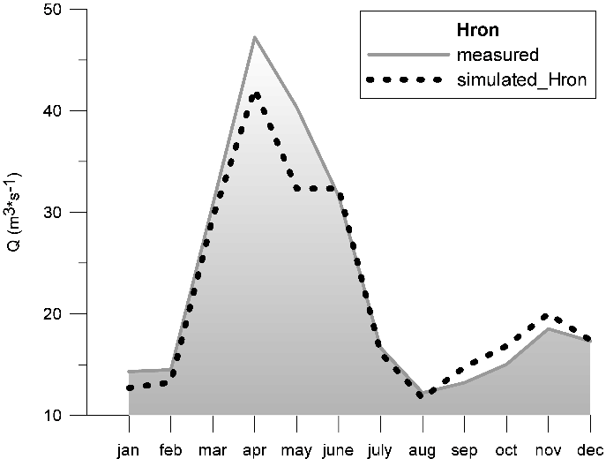

Fig. 4. Comparison of the simulated and measured mean daily discharges for the selected year of 1995 and the long-term mean monthly discharges for the calibrated period at the outlet of the Hron River Basin in Banská Bystrica.

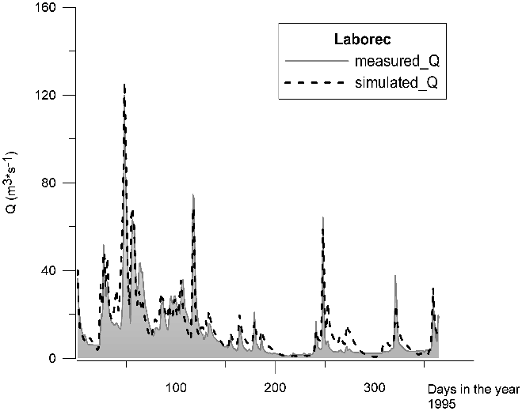 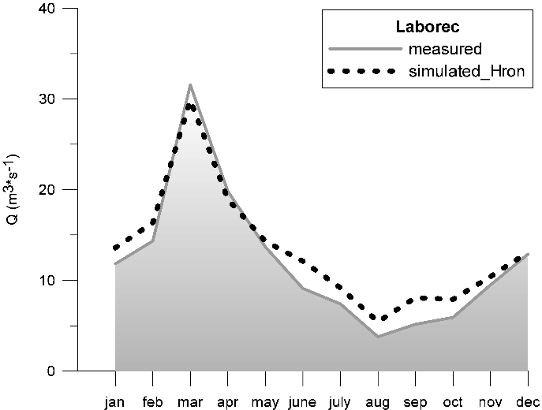

Fig. 5. Comparison of the simulated and measured mean daily discharges for the selected year of 1995 and the long-term mean monthly discharges for the calibrated period at the outlet of the Laborec River Basin in Humenné.

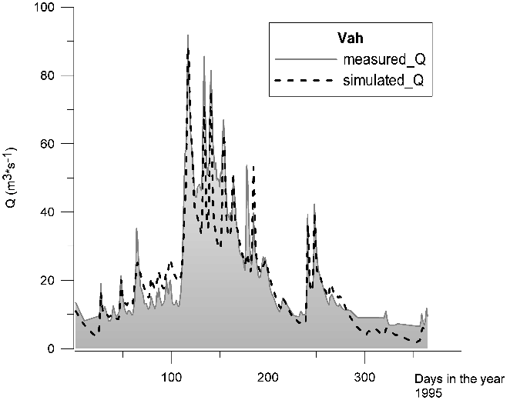 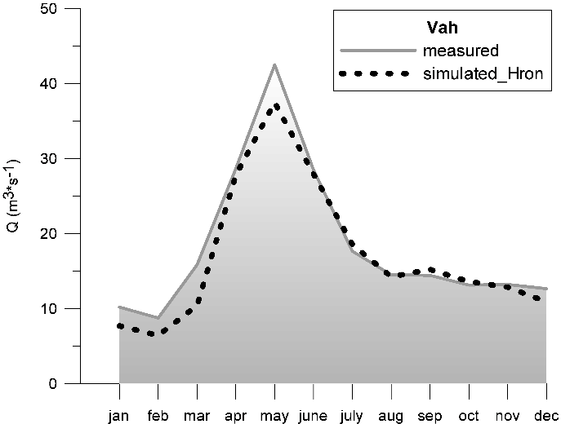

Fig. 6. Comparison of the simulated and measured mean daily discharges for the selected year of 1995 and the long-term mean monthly discharges for the calibrated period at the outlet of the Váh River Basin in Liptovský Mikuláš.

The suitability of the calibrated parameters for the simulation of the future runoff regime was tested on a subsequently measured data set for the period 1996–2010 for each river basin. The results of the validation for each river basin are illustrated in Fig. 7 by a graphic comparison of the simulated and measured long-term mean monthly discharges at the river basin outlets.

When comparing the results of the validation for each basin, it is also necessary to take into account the length of the validation period. Presumably, the longer the validation period is, the lower the N-S coefficient we obtain, due to the higher possibility of the occurrence of different hydrological events.

The results achieved from calibrating and validating the parameters of the Hron model for the selected river basins were at a relatively good level. The differences between the calibration and validation periods occur particularly in the month of July. These differences were due to changes in the discharges after the year 1995, when there was a noticeable rise in discharges and a higher frequency of high flows. The simulated long-term mean monthly discharges in July reached a high degree of compliance with the measured data for the calibration period (1981-1995); in the validation period there was a problem with their simulation, and conversely. The most significant impact of the changed flows on the model parameters after the year 1995 was observed for the Váh River basin. In other basins there was also an increase in the maximum flows in the validation period; however, the simulated parameters were able to simulate these changes quite well for both the calibration and validation periods.

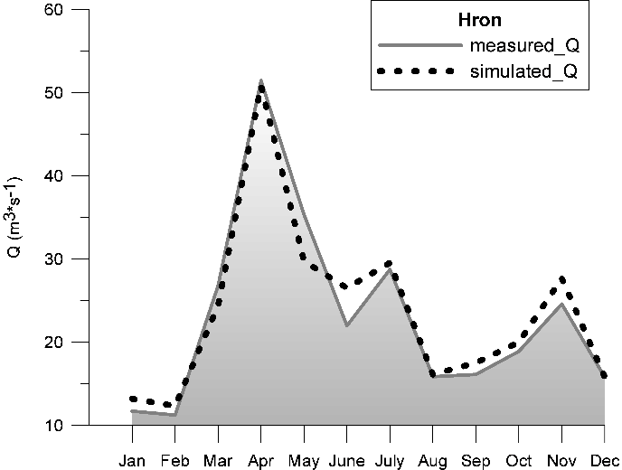 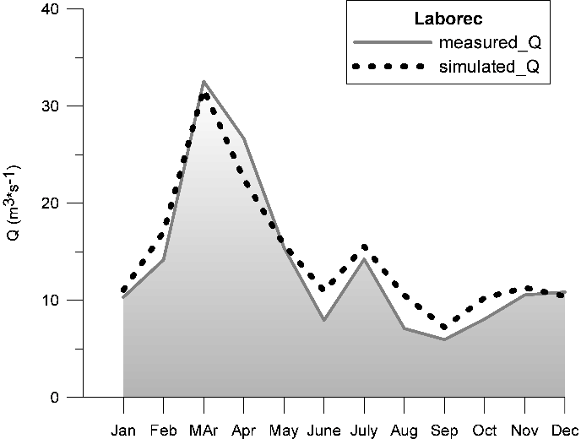

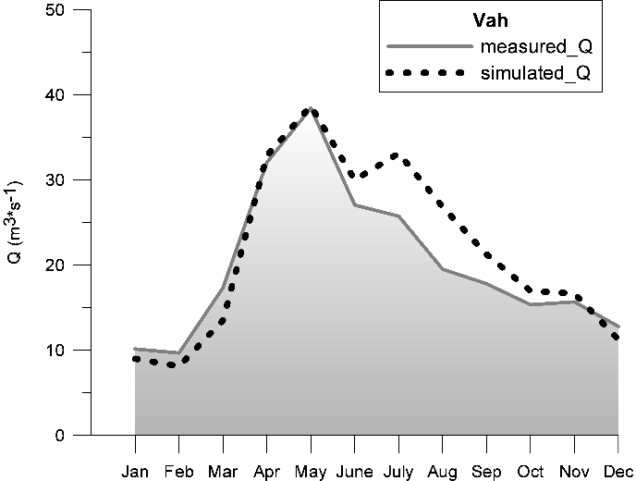

Fig. 7. Comparison of the simulated and measured long-term mean monthly discharges at the outlets of the river basins for the validation period.

1. Changes in the simulated runoff in future decades

Changes in the runoff for the future time horizons of 2021-2050 and 2071-2100 compared to the reference period of 1961-1990 were evaluated on the basis of expected changes in precipitation and air temperature under the following different climate change scenarios: ALADIN-Climate, KNMI and MPI. To simplify the graphic outputs, the ALADIN-Climate scenario is called “Aladin”.

The redistribution of the runoff within the year was expressed as the long-term mean monthly discharges in the future time periods and their changes in comparison with the present stage. They are processed in tabular forms (Tables 2, 3 and 4) and graphically. The graphs were only processed for the more extreme period of 2071-2100 and illustrate the changes in percentages in the long-term mean monthly discharges under different scenarios compared to the reference period (Figs. 8, 9 and 10).

Table 2. Changes in the long-term mean monthly discharges for the future time horizons of 2021-2050 and 2071-2100 compared to the reference period of 1961-1990 (according to the three different climate change scenarios) for the Hron River basin.

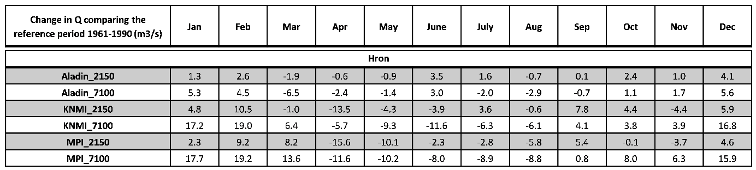

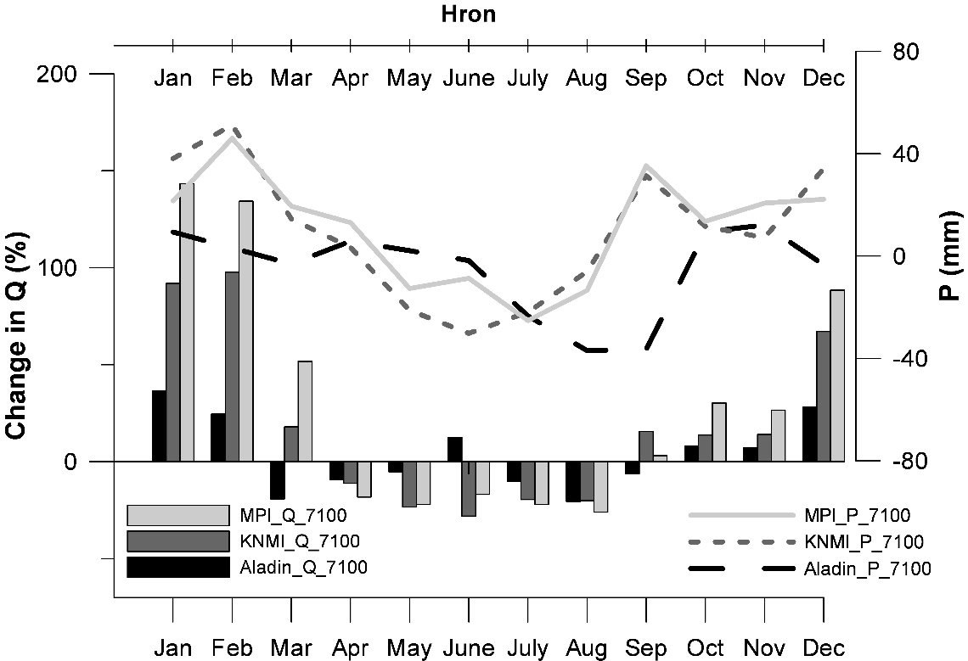

Fig. 8. Percentage changes in the long-term mean monthly discharges for the future time horizons of 2071-2100 compared to the reference period of 1961-1990 (according to the three different climate change scenarios) for the Hron River basin.

Table 3. Changes in the long-term mean monthly discharges for the future time horizons of 2021-2050 and 2071-2100 compared to the reference period of 1961-1990 (according to the three different climate change scenarios) for the Laborec River basin.

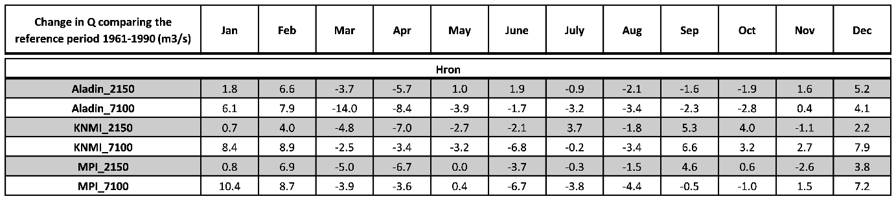

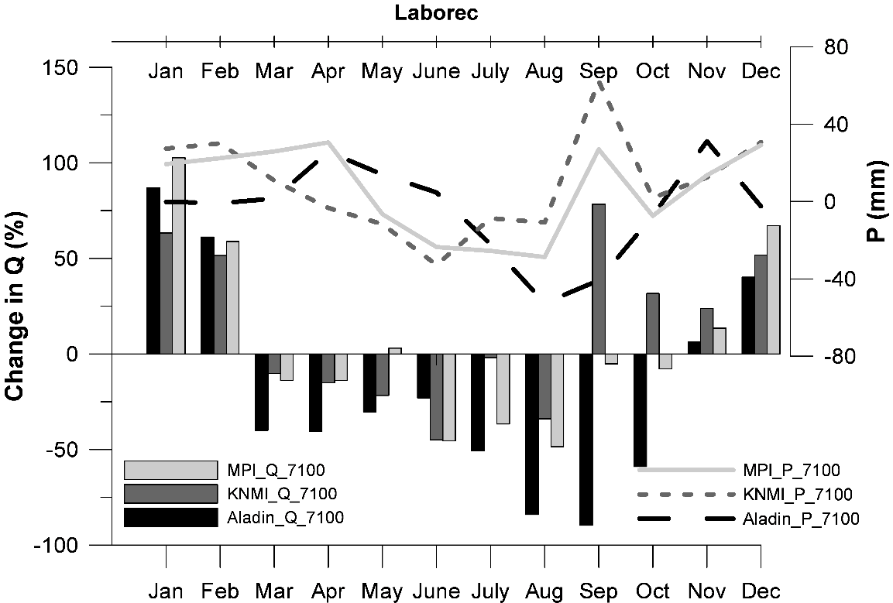

Fig. 9. Percentage changes in the long-term mean monthly discharges for the future time horizons of 2071-2100 compared to the reference period of 1961-1990 (according to the three different climate change scenarios) for the Laborec River basin.

Table 4. Changes in the long-term mean monthly discharges for the future time horizons of 2021-2050 and 2071-2100 compared to the reference period of 1961-1990 (according to the three different climate change scenarios) for the Váh River basin.

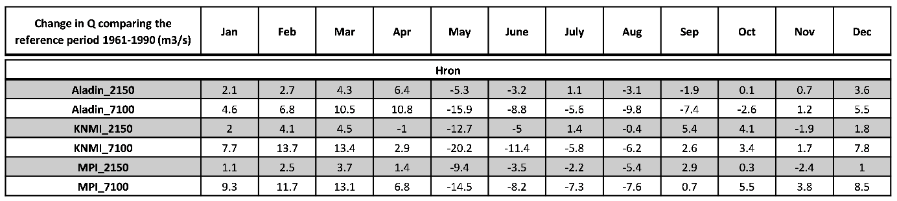

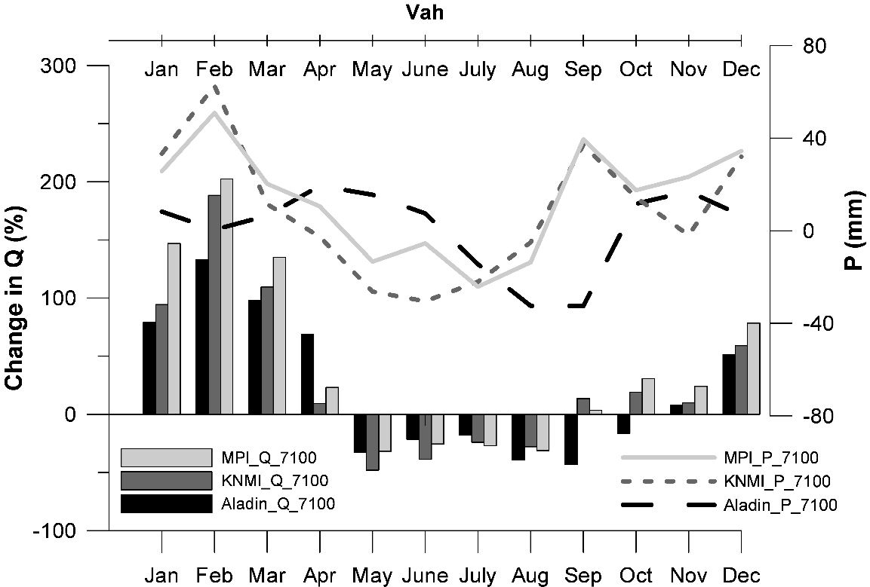

Fig. 10. Percentage changes in the long-term mean monthly discharges for the future time horizons of 2071-2100 compared to the reference period of 1961-1990 (according to the three different climate change scenarios) for the Váh River basin.

The results of the runoff simulation under changed climate conditions show that changes in the long-term mean monthly discharges are expected to be more or less the same according to all the climate change scenarios used. During the winter period (possibly in the early spring), an increase in runoff can be expected; a decrease in runoff can be assumed in the spring and summer periods. Such results were also documented in the study of Middelkoop, et al. (2001). The autumn is the only season where the results vary depending on the climate change scenario. The MPI and KNMI scenarios foresee an increase in the fall runoff; the ALADIN-Climate scenario assumes a decrease in runoff up to October.

Overall, the most significant decrease in the long-term mean monthly discharges in the summer is expected for the Laborec River basin, which is the lowest located river basin of all the river basins studied. This fact, together with higher temperatures, may cause a decrease in the monthly flow up to 90%.

We expect the most significant increase in the long-term mean monthly discharges for the Laborec and Hron River basins in January, which could probably be caused by the changing of the snowfalls into rain due to the increasing air temperature. Only for the Váh River basin we expect a maximum increase in the long-term mean monthly discharges in February. This may be caused by increasing rainfall and higher altitudes of this basin. The Váh River basin is the highest located river basin within the three basins investigated. At these altitudes we assume there is a greater amount of snow cover. Therefore, with the increase in the air temperature we can expect not only the changing of snowfalls into rain but also more intensive snow melts. This justifies a longer-term increase in runoff (until April), compared to the remaining basins and also a greater increase in runoff in the month of February. The most significant increase in runoff is expected for the months of January and February according to the MPI scenario.

The highest percentage increase in long-term mean monthly runoff according to the MPI scenario is assumed for the Váh River basin (205%). For the other basins an increase is estimated in the long-term mean monthly runoff between 100-145%.

Conclusion

The outcomes of the runoff simulation under changed climate conditions indicate that changes in the long-term mean monthly discharges are expected to be similar according to all the climate change scenarios used. The small differences are mostly caused by the differences in precipitation; particularly for the Aladin-Climate scenario in comparison with the MPI and KNMI RCMs. Regardless of this fact, it could generally be concluded for all the scenarios investigated that during the winter and early spring periods, an increase in the long-term mean monthly runoff could be assumed. The period of an increase in runoff could occur from November/December to February/April. This increase could be caused by an increase in air temperature and a shift in the snow melting period from the spring months to the winter period. The period of a decrease in runoff could occur from March/April to September/November. The increase in winter runoff and the decrease in summer runoff are expected to be more extreme for the later time horizons.

The consistency between the simulated results of the changes in the seasonal runoff regime for all the RCMs considered confirms the need for adaptive measures to be taken to reduce the impacts of climate change in the future. According to the anticipated changes in the seasonal distribution of the mean monthly discharges, all the river basins investigated could become vulnerable to drought in the summer and early autumn. In months with increased water demands for irrigation, domestic and industrial use, and tourism, the monthly discharges could exhibit a decrease under conditions of climate change. The intensity of the changes could increase towards the time horizon of 2070-2100. A continuing general decrease in the utilizable potential of water resources is likely to occur, which will have to be taken account of in the planning and management of water resources.

**Acknowledge**

This work was supported by the Slovak Research and Development Agency under Contract No. APVV-0303-11 and VEGA Agency under Contract No. 1/0908/11.

1. References

Alexandru, A., R. de Elia, R. Laprise, L. Separovic, and S. Biner, 2009: Sensitivity Study of Regional Climate Model present climate simulation. Climate Dynamics, **35**, 721-740.

Bresson, R., and R. Laprise, 2011: Scale-decomposed atmospheric water budget over North America as simulated by the Canadian Regional Climate Model for current and future climates. Climate Dynamics, **36**, 365-384.

Cha, D., D. Lee, and S. Hong, 2008: Impact of boundary layer processes on seasonal simulation of the East Asian summer monsoon using a Regional Climate Model. Meteorology and Atmospheric Physics, **100**, 53-72.

Crétat, J., B. Pohl, Y. Richard, and P. Drobinski, 2012: Uncertainties in simulating regional climate of Southern Africa: sensitivity to physical parameterizations using WRF. Climate Dynamics, **38**, 613-634.

Danihlík, R., Hlavčová, K., Kohnová, S., Parajka, J., Szolgay J., 2004: Scenarios of the change in the mean annual and monthly runoff in the Hron Basin. J. Hydrol. Hydromech., 52, 2004, 4, 291-302.

Diffenbaugh, N., M. Ashfaq, and M. Scherer, 2011: Transient regional climate change: Analysis of the summer climate response in a high-resolution, century-scale ensemble experiment over the continental United States. Journal of Geophysical Research-Atmospheres, **116**, D24111.

Halmová, D., 2006: Impact of expected climate change on storage volume utilisation of important water reservoir of the Slovak Republic. In: Stevan Bruk, Tioslav Petkovic, eds.: 23rd Conference of the Danubian countries on the hydrological forecasting and hydrological bases of water management, Belgrade - Serbia, 10 pp.

Halmová, D., Melo M., 2006: Climate change impact on reservoir water supply reliability. IAHS-AISH Publication, Wallingford, 308, 407-412.

Hernández-Díaz, L., R. Laprise, L. Sushama, A. Martynov, K. Winger, and B. Dugas, 2013: Climate simulation over CORDEX Africa domain using the fifth-generation Canadian Regional Climate Model (CRCM5). Climate Dynamics, **40**, 1415-1433.

Hlavčová K., Kalaš M., Szolgay J., 2002: Impact of climate change on the seasonal distribution of runoff in Slovakia. Slovak Journal of Civil Engineering, X, 2, 10−17.

Hlavčová K., Kohnová S., 2005: Návrh rámcových adaptačných opatrení. In: Pekárová, P., Szolgay, J., eds.: Scenáre zmien vybraných zložiek hydrosféry a biosféry povodí Hrona a Váhu v dôsledku klimatickej zmeny. Veda – Vydavateľstvo SAV, Bratislava, 419-492, ISBN 80-224-0884-0.

Hlavčová, K., Szolgay, J., Kohnová, S., Hlásny, T., 2008: Simulation of hydrological response to the future climate in the Hron river basin. Journal of Hydrology and Hydromechanics, 56, 3,  163-175.

Kawazoe, S., and W. Gutowski, 2013: Regional, very heavy daily precipitation in NARCCAP simulations. Journal of Hydrometeorology, doi:10.1175/JHM-D-12-068.1.

Kostka Z., 2003: Changes in hydrological processes in mountainous regions in interaction with changing environment. Acta Hydrologica Slovaca, 4, 1, 190-196.

Kostka Z., Holko L., 2000: Impact of climate change in a small mountain catchment. Publication of National Climate Programme of the Slovak Republic, No. 9. SHMI, ME SR, Bratislava, 91−109.

Kostka Z., Holko L., 2001: Impact of vegetation changes on river runoff in a small mountain catchment. Publication of National Climate Programme of the Slovak Republic, No. 10. SHMI, ME SR, Bratislava, 82-93.

Lapin, M, Bašták-Ďurán, I., Gera, M., Hrvoľ, J., Kremler, M., Melo, M., 2012: New climate change scenarios for Slovakia based on global and regional general circulation models. Acta Met. Univ. Comen., 37, 25-74.

Lapin, M., Gera, M., Hrvoľ, J., Melo, M. & Tomlain, J. , 2009: Possible impacts of climate change on hydrological cycle in Slovakia and results of observations in 1951-2007. Biologia 64 (3): 454-459.

Lapin, M., Melo, M., 2004: Methods of climate change scenarios projection in Slovakia and selected results. Journal of Hydrology and Hydromechanics, 52, 2004, 4, 224-238.

Laprise, R., et al., 2008: Challenging some tenets of Regional Climate Modelling. Meteorology and Atmospheric Physics, **100**, 3-22.

Macurová, Z., Hlavčová, K., Lapin, M., Szolgay, J., Kohnová, S., 2010: Impact of climate change on daily discharges in the upper Hron River basin. Meteorological Journal, 13, 2, 45-53.

Macurová, Z., Výleta, R., Hlavčová, K., Szolgay, J., Kohnová, S., 2012: An analysis of the iImpact of climate change on the Laborec River Basin using two different hydrological models. Acta Hydrologica Slovaca, 13, 1, 242-253.

Majerčáková O., Takáčová D., 2001: Possible impact of climate change on groundwater in alluvial fans. Publication of National Climate Programme of the Slovak Republic, No. 11. SHMI, ME SR, Bratislava 2001, 31−49.

Maurer, E. P., L. Brekke, T. Pruitt, and P. B. Duffy, 2007: Fine-resolution climate projections enhance regional climate change impact studies, Eos Trans. AGU, 88(47), 504–504, doi:[10.1029/2007EO470006](http://dx.doi.org/10.1029/2007EO470006" \o "Link to external resource: 10.1029/2007EO470006).

Pekárová P., Miklánek P., 2001: Increase of floods extremality on the Uh river. International Conference on Water and Nature Conservation in the Danube-Tisza River Basin, Magyar Hidrológiai Társaság, 469−480.

Pekárová P., Miklánek P., Pekár J., 2001: Analysis of runoff fluctuation in the moderate and subarctic regions. Acta Hydrologica Slovaca, 2, 1, 122−129.

Pekárová P., Szolgay J., eds., 2005: Assessment of Climate Change Impact on Selected Components of the Hydrosphere and Biosphere in the Hron and Váh River Basins. VEDA, Bratislava 2005, 419-492, ISBN 80-224-0884-0.

Rummukainen, M., 2010: State-of-the-art with regional climate models. Wiley Interdisciplinary Reviews: Climate Change, 1, 82-96.

Slovak National Communication on Climate change, 2009: <http://unfccc.int/resource/docs/natc/svk_nc5.pdf>

SRES IPCC, 1999: <http://www.ipcc.ch/ipccreports/sres/emission/index.php?idp=0>

Szolgay J., Hlavčová K., Kalaš M., 2002: Estimation of climate change impact on runoff regime. Journal of Hydrology and Hydromechanics, 50, 4., 341−371.

Szolgay J., Hlavčová K., Lapin M., Danihlík R, 2003: Impact of climate change on mean monthly runoff in Slovakia. Meteorological Journal, 6, 3, 9−21.

Szolgay J., Hlavčová K., Lapin M., Kohnová S., Parajka J., 2007: Impact of climate change of runoff regime in Slovakia. KEY Publishing, Ostrava, 160 pp. (in Slovak)

Szolgay J., Hlavčová K., Parajka J., Kohnová S., Bálint G., 2007: Combined grid-based and conceptual approach to climate change impact estimation for water resources planning. In: Heinonen, M., ed.: Proceedings of the Third international conference on Climate and Water. Finnish Environment Institute SYKE, Helsinki 2007, 449-454.

Štěpánek, P., Skalák, P., Farda, A. 2008: RCM ALADIN-Climate/CZ simulation of 2020-2050 climate over the Czech Republic. In: Rožnovský, J., Litschmann, T. (ed): Bioklimatologické aspekty hodnocení procesů v krajině, Mikulov 9. – 11.9.2008, ISBN 978-80-86690-55-1.

UN FCCC, 1992: <http://en.wikipedia.org/wiki/United_Nations_Framework_Convention_on_Climate_Change>

UNFCCC, 2013: <http://unfccc.int/2860.php>

WMO, 2013: Guide to Climatological Practices, WMO No. 100. <http://www.wmo.int/pages/prog/wcp/ccl/documents/WMO_100_en.pdf>